**IRS 1095-B Tax Form (Proof of Health Coverage)**

**User Guide**

**August 2022**

**Depart of Veterans Affairs**

**Office of Information and Technology (OI&T)**

**Table of Contents**

1. Introduction 3

1.1. Purpose 3

1.2. Document Orientation 3

1.2.1. Organization of Manual 3

1.2.2. Assumptions 3

2. IRS 1095-B Tax Form Overview 3

2.1. User Access 4

2.1.1. Who can access this form? 4

2.1.2. How can users access this form? 4

2.2. Navigation 4

3. 1095-B Download Functionality 7

3.1. Accessing the form 7

3.1.1. If not signed in 7

3.1.2. If already signed in 8

3.2. The IRS 1095-B Health Coverage Form 9

3.3. Opting in for Paperless Delivery only 11

4.1. Errors and Escalation 11

4.1.1. Error States 11

4.1.2. Escalation Path 12

**Table of Figures**

**Figure 1 User sign in screen for va.gov.** 4

**Figure 2 VA Benefits and Health Care drop-down menu with link to records hub highlighted.** 5

**Figure 3 1095-B link highlighted on Records Hub.** 6

**Figure 4 The unauthenticated (not signed-in) look of the 1095-B landing page.** 7

**Figure 5 The authenticated (signed-in) look of the 1095-B landing page.** 8

**Figure 6 Sample pdf download output of IRS 1095-B tax form.** 9

**Figure 7 Sample Text file output for the 1095-B tax form.** 10

**Figure 8 Information box with action link to sign up for paperless delivery.** 11

**Figure 9 State change and message shown after successful download.** 11

**Figure 10 State change for message "You don't have 1095-B tax form available right now."** 12

**Figure 11 State change for error message, "We couldn't download your form."** 12

**Figure 12 Document last updated and how to change your address.** 13

# **1.** **Introduction**

## **1.1.** **Purpose**

The purpose of this User Guide is to provide instruction to those wishing to access and download the IRS 1095-B tax form online from Va.gov.

## **1.2.** **Document Orientation**

### 1.2.1. Organization of Manual

This User Guide is divided into four sections to allow you to quickly obtain the information you need.

The first section will provide an introduction and overview of this document.

The second section will give an overview of the IRS 1095-B tax form and walk through how one would navigate to find and download the form from the Va.gov site.

The third section will cover download functionality, to include: choosing document format, downloading the form and what the form looks like.

The fourth section will cover error states and escalation paths.

### 1.2.2. Assumptions

This guide was written with the following assumed experience/skills of the audience:

* User has basic knowledge of using the internet and web browsers.
* User is registered for VA health benefits and has a DS Logon Premium, MHV Premium, or ID.me account.

# **2.** **IRS 1095-B Tax Form Overview**

IRS Form 1095-B reports the months a person had qualifying minimum health coverage to the IRS. Currently the VA mails this form out to Veterans at the beginning of the year (between December and March). The process is costly, and many are returned to due inaccurate address. In order to ensure delivery to Veterans and to decrease some of the costs associated with mailing this form, we have now made the 1095-B available for online access via digital download of a pdf from their records on Va.gov.

Changes to the Affordable Care Act have reduced the federal tax penalty for not having health coverage to $0; so, in most cases the 1095-B will simply be a document to keep for one's records. As of March 2022, six states—Massachusetts, New Jersey, Vermont, California, Rhode Island and District of Columbia (Washington D.C.)—still have individual coverage mandates that may result in penalties for not being insured and so Veterans should refer to any local IRS instructions, as applicable, for retaining this form and filing their state taxes.

Target launch date: September 2022 for MVP

## **2.1.** **User Access**

### 2.1.1. Who can access this form?

Veterans enrolled in VA health benefits with a VA.gov account.

### 2.1.2. How can users access this form?

Users can log in using their DS Logon Premium, MHV Premium, or ID.me accounts.

**Figure 1 User sign in screen for va.gov.**

## **2.2.** **Navigation**

**Direct url:** <https://www.va.gov/records/download-your-irs-1095-b>

**Or** the link to download the IRS 1095-B tax form can be found by way of the VA Benefits and Health Care dropdown menu (top navigation) on the Records Hub Page: <https://www.va.gov/records/>

By clicking “view all in records,” the Veteran can then find the link labeled “Download your IRS 1095-B tax form.”

**Figure 2 VA Benefits and Health Care drop-down menu with link to records hub highlighted.**

**Figure 3 1095-B link highlighted on Records Hub.**

# **3.** **1095-B Download Functionality**

## **3.1.** **Accessing the form**

### 3.1.1. If not signed in

If the Veteran navigates to the form while not logged in, they will be prompted to do so on the page.

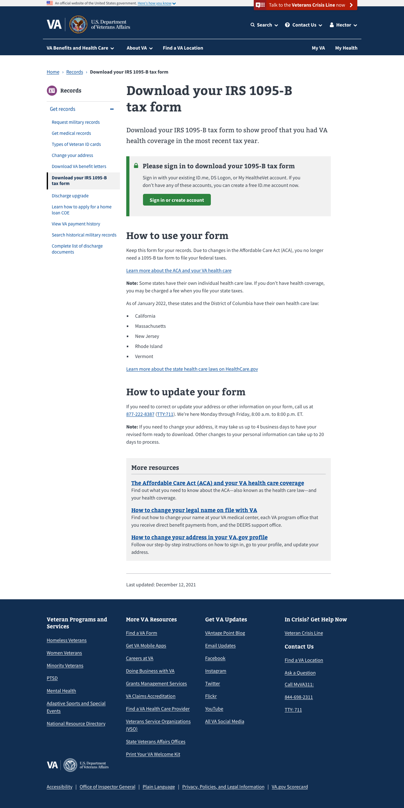

**Figure 4 The unauthenticated (not signed-in) look of the 1095-B landing page.**

### 3.1.2. If already signed in

Once the Veteran is on the page, they will have an option to choose the format of their document download. Options are provided for PDF or Text file. PDF is a common document format that mimics the look of the paper form and is easily printable. Text is an approved IRS alternate document format that works well for those who may be using a screen reader or other assistive technology.

After the Veteran has selected the radio button for their desired document format, they can click the blue primary action button, “Download your 1095-B tax form.”

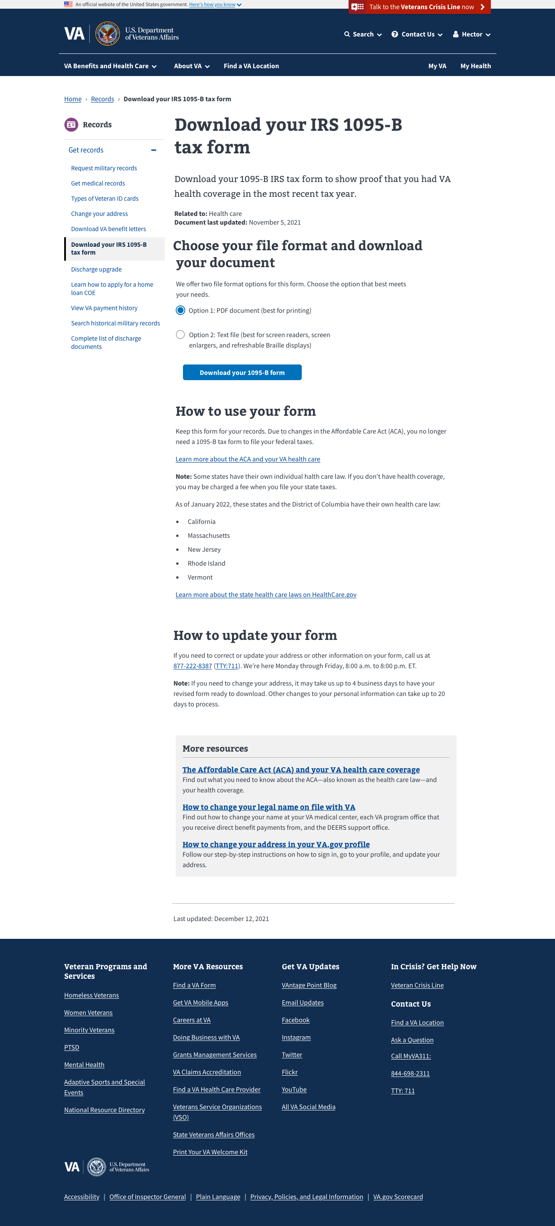

**Figure 5 The authenticated (signed-in) look of the 1095-B landing page.**

## **3.2.** **The IRS 1095-B Health Coverage Form**

The 1095-B is downloaded as a pdf file and pre-populated with all the Veteran’s information: Name, social security number, address and months of coverage. This information is present on both formats of the document, PDF and Text file.Table

**Figure 6 Sample pdf download output of IRS 1095-B tax form.**

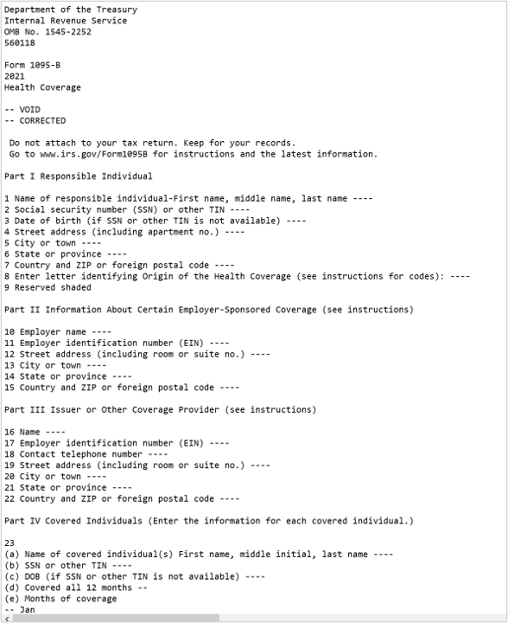

**Figure 7 Sample Text file output for the 1095-B tax form.**

## **3.3.** **Opting in for Paperless Delivery only**

In order to reduce paper waste and costs associated with mailing the 1095-B, an option for paperless delivery only is being made available to Veterans. On the 1095-B landing page, below the download button in a gray information box is a callout for “Sign up for paperless delivery.” A Veteran may select the linked action button here to be redirected to their VA.gov profile where they can choose how they would like to receive their 1095-B—in the mail or digital. They can also complete this task by navigating to their profile directly via the top navigation. Once a Veteran has opted-in for paperless delivery only, they will no longer receive the 1095-B in the mail until this setting is changed again.

**Figure 8 Information box with action link to sign up for paperless delivery.**

# **4.1.** **Errors and Escalation**

## **4.1.1. Error States**

In most cases, after clicking the download button Veterans will know that they have successfully downloaded the 1095-B by a change in state—the text above the box will now read “Download complete.”

**Figure 9 State change and message shown after successful download.**

However, in certain cases the Veteran may not be able to download their 1095-B as expected. If they have just registered for health care with the VA and do not have data on file for the previous year, they will receive the following message:

**Figure 10 State change for message "You don't have 1095-B tax form available right now."**

If there is a technical error on the site and the form is not able to be generated, the Veteran will receive this message:

**Figure 11 State change for error message, "We couldn't download your form."**

In the event that the download toggle for the 1095-B form is turned off for maintenance, the Veteran will receive this message:

**Figure 12 State change for alert when download toggle is turned off.**

## **4.1.2. Escalation Path**

Veterans can call the Health Benefits Hotline at 1-877-222-8387 to update their address and/or fix any additional errors noticed on the form. Once a representative answers the phone, the Veteran should tell them that there is an error on their 1095-B form. The representative will ask for the correct information and update it in the enrollment system.

**Figure 13 Document last updated and how to change your address.**

Veterans should refer to the “Document last updated” date above the 1095-B download link to make sure that they are downloading the most recent version of the form. Changes to a Veteran’s address may take up to 4 business days to process and generate a new version of 1095-B online. Changes to other personal information outside of mailing address, such as corrections to date of birth or social security number take additional processing time and may take up to 20 business days for the Veteran to receive an updated copy of their 1095-B.